37.27: a) 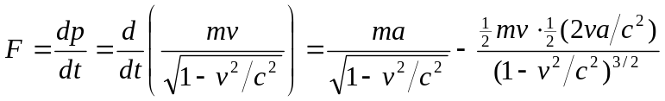
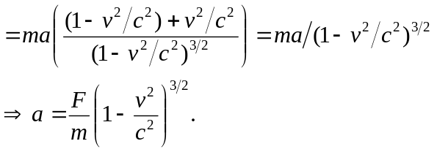
b) If the force is perpendicular to velocity then denominator is constant 